Request for Proposal (RFP)

Subject: Request for Proposal (RFP) for ‘Procurement with printing of Executive Office file’ for Vihaan Programme
Ref. No. HLFPPT/NOIDA/Vihaan/2
Date : 03.04.2014
Requested by:
Hindustan Latex Family Planning Promotion Trust (HLFPPT),
B-14 A, II Floor, Sector 62, Gautam Budh Nagar, NOIDA- 201301
Ph: 0120-4673673- Extn.-336
Website: www.hlfppt.org

Organization Profile: Hindustan Latex Family Planning Promotion Trust (HLFPPT) constituted in year 1992 as a not for profit organization, promoted by HLL Lifecare Limited (A Government of India Enterprise) to work on various Reproductive and Child Health (RCH) issues with a vision to offer innovative solutions for better health. HLFPPT is registered as a society under the Travancore Cochin Charitable Trust Act. HLFPPT is one of the leading Non Government Organization in India, working in close association with the community for improving their lives through, Social Marketing of Products and Services, Social Franchising of clinical health care, Planning & Implementation of HIV/AIDS, Prevention & Care Programmes and Consultancy.

Hindustan Latex Family Planning Promotion Trust is Sub- Recipient (SR) for phase II of the Global Fund Round 4 RCC grant through Alliance India , named ‘Vihaan’, a Sanskrit word mean ‘dawn’s first light’. This programme is being implemented with a key objective to improve the survival and quality of life of PLHIV by establishing Care & Support Centers (CSCs) in Punjab & Chhattisgarh State as part of national effort to improve treatment outcomes and meet the needs of PLWHA, including those who are members of high-risk groups, women and children, over the next three years (2013-16). Presently the project is being implemented through 7 Sub-Sub Recipient (SSR) partners in 8 district of Punjab & Chhattisgarh States.

Scope of work:
Request for Proposal for procurement with printing of Executive Office file at Corporate Office, B-14A, Sector-62, Noida-201307 (U.P.).
Submission of bid:
Interested parties can send their quotations with complete details in form of Annexure ‘A’ (Technical Bid) and Annexure ‘B’ (Financial Bid) to Biswanath Padhy National Manager Finance - at HLFPPT, B-14A, 2nd Floor, Sector-62, Noida -201307 (U.P.) on any working day up to 11.00 hours on or before 09.04.2014. The same can be downloaded from our website: http://hlfppt.org/tender.html. For any further information please contact Mr. Neeraj Pathak, contact no. 0120-4673600 Extn. 336
The Technical and Financial Bid must be submitted in separate sealed envelopes clearly super-scribing “Technical Bid” or “Financial Bid” for Procurement with printing of Executive Office file on them. Both the sealed envelopes should be kept in a third sealed envelope super-scribing “Request for Proposal for Procurement with printing of Executive Office file”

Terms & conditions:

The bidding is open to all qualified bidders who fully meet the following minimum qualifying requirements and provide satisfactory evidence in support, failing which their bid may be rejected:

- The bidder must have PAN (Permanent Account Number).with the Sales/Service Tax departments and the registration documents/certificate for the same to be attached.

- The bidder must have average annual turnover of 10 lakh during immediately preceding last 3 year. CA certificate or audited Balance Sheet of last 3 years should be enclosed with the technical bid for proof of the same.
- The Rate offered by the agency should be valid for six month.

- The Bidder should provide brief profile of their work experience along with client list.

- The bid received through FAX/ E-mail or received late due to postal delay etc. will not be accepted. The bidders have to ensure the receipt of bids well in time.

- Those who are not technically qualified will not be entertained in financial bid.

- Bidders should quote their unconditional rates strictly in the prescribed Performa, cutting, over-writing, if any, should be duly counter-signed.

- The payment will be made within 30 days on receipt of invoice and delivery of file in good condition.

- TDS as applicable will be deducted as per IT rules.

- The competent authority reserves the right to accept or reject any bid in full or part without assigning any reason thereof. The decision of the competent authority in this regard shall be final and binding on the firm.

- The Bidder shall submit all necessary documentary evidence to establish that the Bidder meets the above qualifying requirements.

- No further discussion/interface will be granted to bidders whose bids have been disqualified. HLFPPT reserves the right to accept or reject in part or full any or all the offers without assigning any reason whatsoever.

- Please note that the cost of preparing a proposal and of negotiating a contract including visits to HLFPPT, if any is not reimbursable as a direct cost of the assignment.

- The RFP shall be evaluated strictly based on the substantive information/credentials/documentary evidences submitted by the agencies.

- The agencies having own printing press preferred.

Annexure “A”
Technical Bid for RFP- Procurement with printing of Executive Office file

a. | Name of the Agency, address, telephone and fax nos.
b. | Name (s) of the Proprietors /  Directors
c. | Partnership Deed/Registration Certificate of the firm to be submitted)
d. | E-mail Address:
e. | Name of the Contact Person  Telephone/Mobile No.
f. | Permanent Account Number: (Copy to be submitted)
g. | TIN No. / Sales Tax No.: (Copy to be submitted)
h. | Service Tax No.: (Copy to be submitted)
i. | List of clients in Delhi/NCR (To be submitted)
J | Company Profile (To be attached)
k | Audited Financial Statement of Last Three year to be attached
l | Having own printing press: | Yes/No
m | If having own printing press, please furnish list of equipment available

I/We hereby declare that all above particulars are correct. I/We have read the terms and conditions of the RFP enclosed with this form duly signed on each page and I/We shall abide the same.

Date: (Signature of bidder)

Place: Address of the firm/Seal……………

Annexure “B”
Financial Bid for Request for Proposal (RFP)
Procurement with printing of Executive Office file
Particular | Specification | Qty | Rate  Per file | Tax | Total Amount ( Inclusive of all taxes  (in Rs.)
CRF Client files | - File type – Corner single tag office file sample mentioned below  - Design – printable Design mentioned in sample file given below.  - The print should be made in single color on front page as given in design (black) | 25000

I/We hereby declare that all above particulars are correct. I/We have read the terms and conditions of the RFP enclosed with this form duly signed on each page and I/We shall abide the same.

Date: (Signature of bidder)

Place: Address of the firm/Seal……………

Undertaking from Vendors

This has reference to the RFP emailed to us. In response to the RFP, we have submitted our technical & financial bids on…………………….. at your office ………………………………………………………………. In connection with the above bids, we hereby declare as under:-

i- That we are neither related to any of your Trustees, Officers and other employees, nor do we have any financial, commercial or other interests with any of the above persons in any capacity whatsoever.

ii- That we have submitted the bids in the name of M/s…………………….......................and declare that no other bids have been submitted by us in the name of any other firms/companies/proprietors/individuals which comes under the same management and related parties.

iii- We hereby undertakes that in case of any violations to the above declarations at any stage of the contract, HLFPPT reserves the sole right to cancel the contract and recover the full value of the contract from us.

For and on behalf of ……………..

(Authorized Signatory with company seal /Stamp.)

Required File Sample
Front
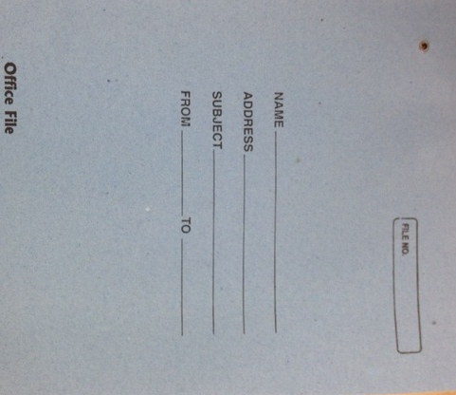
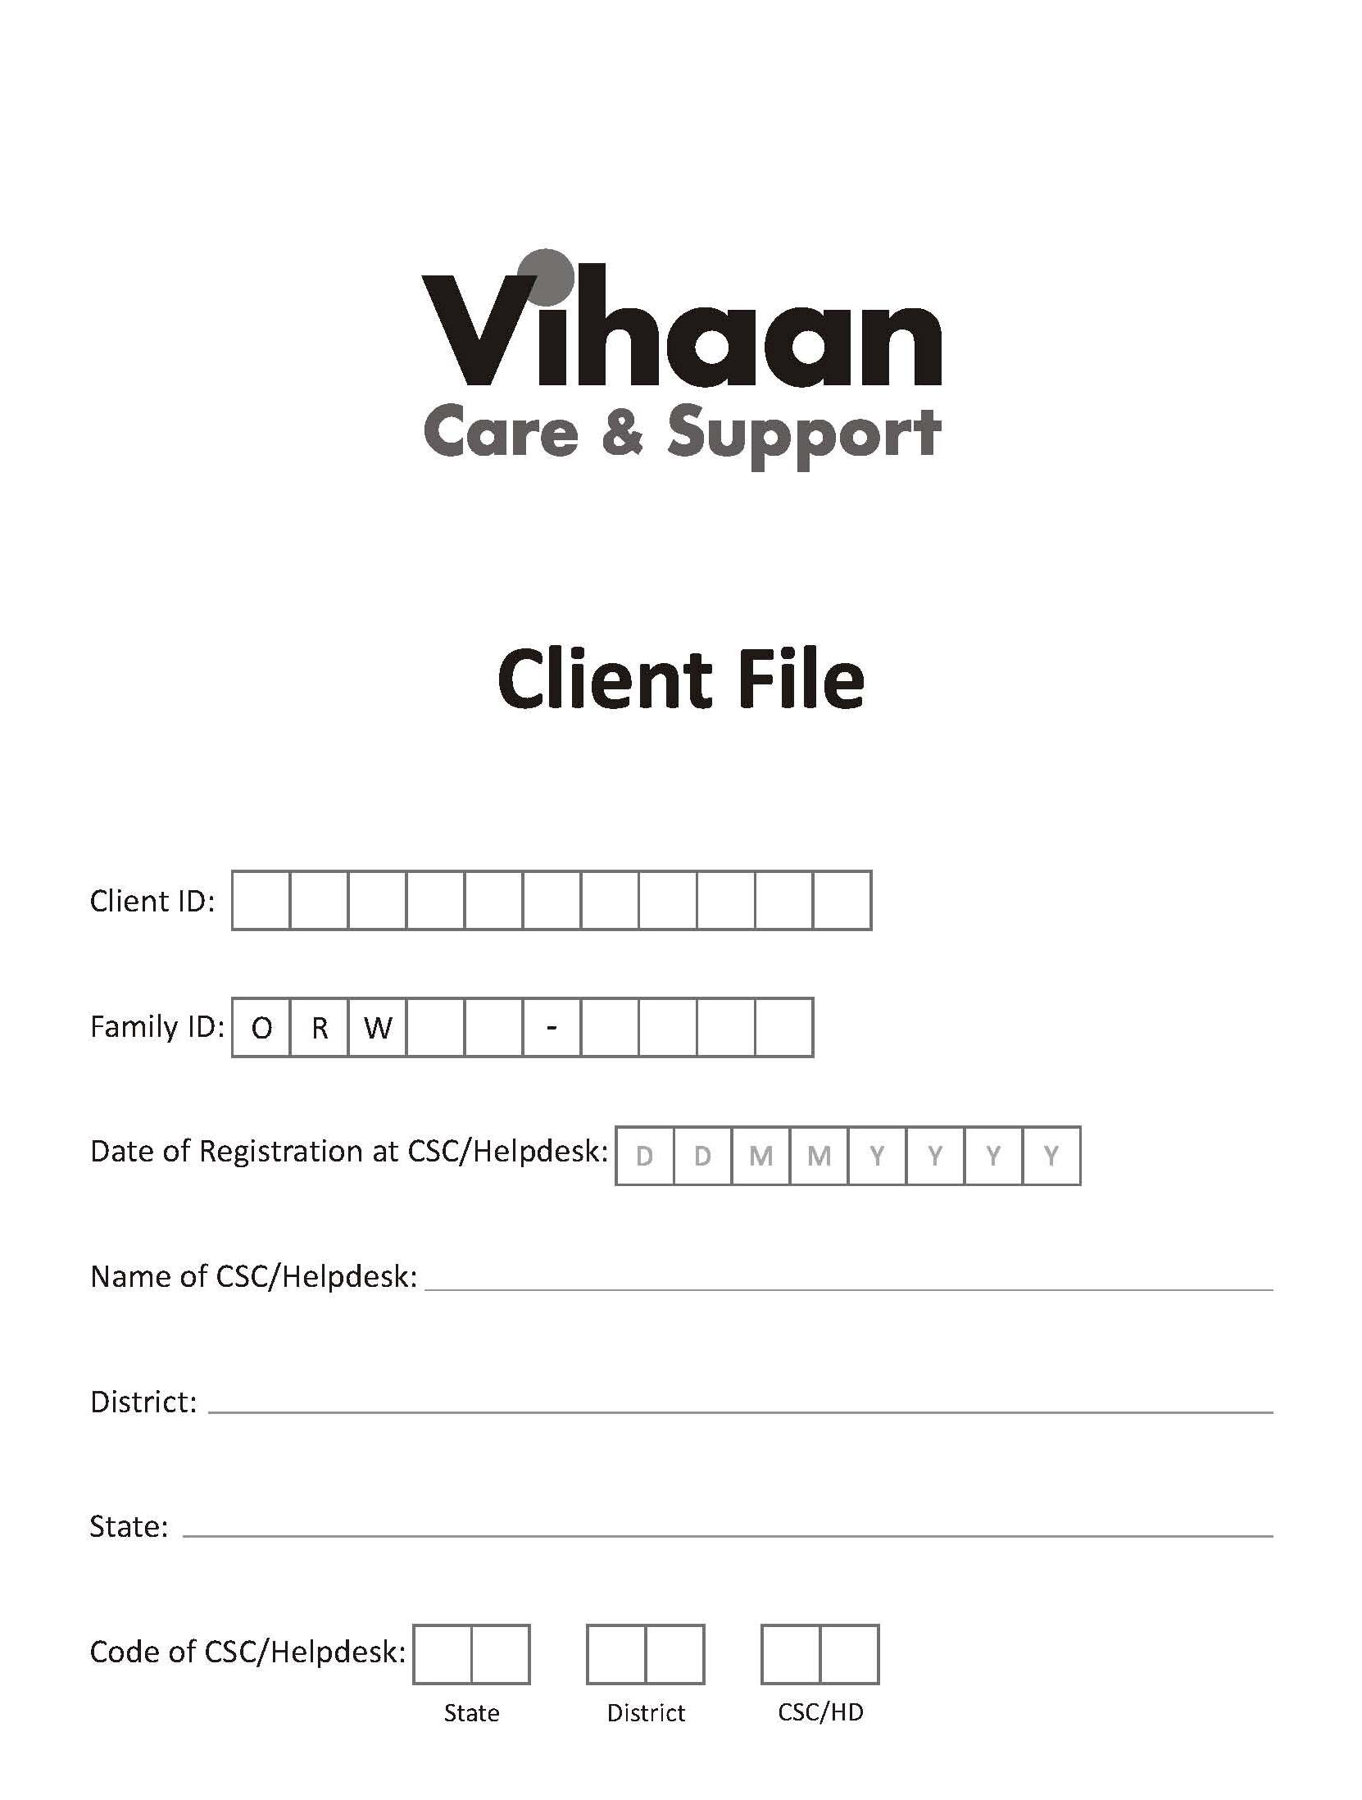

Inner

