Hindustan Latex Family Planning Promotion Trust (HLFPPT)

Request for Proposal (RFP)

Ref: HLFPPT/CSR/MMU/LKO/2016-17

for

Supplying, Operating & Maintaining one Mobile Medical Unit vehicle in Mohanlalganj, Lucknow, Uttar Pradesh

Hindustan Latex Family Planning Promotion Trust
(A Trust Promoted by HLL Lifecare Ltd.)
HO: B-14 A, Sector-62,
Gautam Budh Nagar, Noida, Uttar Pradesh – 201 307
T: +91 120-4231060/1
E: csr@hlfppt.org
W: www.hlfppt.org

June 7, 2016

Contents
Section I: Request for Proposal 2
Section II: Instruction to Bidders 3
A. GENERAL 3
B. BID DOCUMENTS 3
C. PREPARATION OF BID 4
D. SUBMISSION OF BID 4
E. AWARD OF CONTRACT 5
F. RELEASE OF WORK ORDER 5
G. MONITORING OF EXECUTION 5
Section III: Scope of Work 5
Section IV: Terms & Conditions 8
Section V: Evaluation Process 8
Section VI: Payment Terms 9
Section VII - Key dates 9
Section VIII – Geography to be Covered 10
1. Annexure A- Format for Receiving the Technical Bid 12
2. Annexure B - Format for Receiving the Financial Bid 17

Section I: Request for Proposal

Hindustan Latex Family Planning Promotion Trust (HLFPPT), B14-A, Sector-62, Noida-201 307 (U.P.) invites proposals from eligible individuals/firms (hereinafter Bidders) for Supply, Operations and Maintenance of one number of Mobile Medical Unit vehicle in Mohanlalganj, Lucknow, Uttar Pradesh. Interested bidders are requested to respond to this Request for Proposal (RFP) with detailed Technical and Financial Bid in the specified formats.

RFP  No. | Name of work & Location | Date of issue of RFP | Last date of receiving Proposal  (at HLFPPT Noida Office)
HLFPPT/ CSR/MMU/LKO/  2016-17 | Supply, Operations and Maintenance of Mobile Medical vehicle in Mohanlalganj, Lucknow, Uttar Pradesh | 07.06.2016 | 17.06.2016 at  18.00 Hrs.

The interested bidder should download the complete set of Request for Proposal (RFP) document comprising Section I to VIII and Annexure A & B from HLFPPT website (www.hlfppt.org) or collect the same in person from the office of HLFPPT, B-14A, Second Floor, Sector-62, Noida-201 307 or collect the same from Ms. Safia Abbas (098390 14420), HLFPPT, 9/316 Vikas Nagar, Lucknow- 226 022, Uttar Pradesh on any working day after the Tender issue date mentioned above.

Prospective bidders are advised to fill, sign and submit hard copies of the bid (Technical Bid – Annexure A and Financial Bid - Annexure B) in two separate sealed envelopes and enclose the two separate envelopes in a master envelope superscripted “Proposal for Supply, Operations & Maintenance of Mobile Medical Unit vehicle in Mohanlalganj, Lucknow, Uttar Pradesh” to the following address on or before 6 pm of 17th June 2016 to:

Mr. Deepak Bahukhandi, Deputy Manager – Internal Audit
Hindustan Latex Family Planning Promotion Trust (HLFPPT)
B-14A, Second Floor, Sector-62
Gautambudh Nagar , Noida-201 307
T: +91 120-4231060/1; F: +91 120-4231065
M: +91 99585 50157: E: dbahukhandi@hlfppt.org

For any queries/ area visit, please contact:
Ms. Safia Abbas, Communication Manager
HLFPPT
9/316 Vikas Nagar, Lucknow- 226 022, Uttar Pradesh,
M: +91-098390 14420, E: sabbas@hlfppt.org

Section II: Instruction to Bidders

A. GENERAL

- Scope of Bid
The detailed description of work, hereinafter referred as ‘work’, is given in the Section III - Scope of Work.

- One Bid Per Bidder
- The bidder can be an individual, an entity or a joint venture. In case of partnership firm and Limited Company, certified copy of partnership deed/ Articles of Association and Memorandum of Association along with registration certificate of the company shall have to be enclosed.
- No bidder shall be entitled to submit more than one bid whether jointly or severally. If one does so, all bids wherein the bidder has participated shall stand disqualified.
- Cost of Bidding
The bidder shall bear all costs associated with the preparation and submission of his bid.

- Area Visit and examination of Surroundings
The bidder is advised to visit and inspect the Area of Operations and its surroundings and obtain for itself on its own responsibility all information that may be necessary for preparing the bid and entering into a contract with HLFPPT. All costs in this respect shall have to be borne by the bidder.

- Eligibility Criteria
The bidder is advised to have following legal documents:
- The Bidder must have PAN
- Bidder must supply registration number with Sales Tax/Service Tax Authorities, (if any). Proof to be enclosed.
- The bidder must have average annual turnover of preceding 3 years of Rs 5 lacs or more. CA certificate or audited profit and loss account of last 3 years [FY 12-13; FY 13-14; and FY 14-15 ] should be attached with Technical bid.

B. BID DOCUMENTS

- Content of bid documents
The Bid Document comprises of the following documents:
  - Technical Bid (Annexure – A)
  - Financial Bid (Annexure – B)

- The bidder is expected to examine carefully all instructions, terms and conditions, specifications etc in the Bid Document. Bidder shall be solely responsible for his failure to do so.

- Queries
Any prospective bidder may raise his queries and/or seek clarifications in writing before the last date of receiving queries as mentioned in Section VII – Key Dates. HLFPPT may at its option, give such clarifications as are felt necessary.

C. PREPARATION OF BID

The bidders have to prepare their bids and submit their signed bids in sealed envelopes as per the time schedule mentioned in the key dates of the Notice Inviting Tenders.

- Documents comprising the bid
The bid submitted by the bidder shall be in the following parts:
- Part 1- this shall be known as Envelope A – Technical Bid and contain all required information and enclosures as per details given in the Annexure A.
- Part 2 – This shall be known as Envelope B – Financial Bid and contain financial offer in the prescribed format enclosed as Annexure B.

- Language
The bid as well as all correspondence and documents relating to the bid exchanged by the Bidder and HLFPPT shall be in English. Wherever any document, for example any government certificate, is furnished in any other language, the bidder shall have to submit an English translation of the same document.

- Technical Bid
- All the documents/ information enclosed with the Technical Bid should be self-attested and certified by the bidder.
- The pages of the Technical Bid should be duly numbered, otherwise it will not be considered for evaluation.

- Financial Bid
  - The bidder shall have to quote rates in Annexure B in absolute amount.
  - The bidder shall have to quote rates inclusive of all duties, taxes, royalties and other levies; and HLFPPT shall not be liable for the failure of the bidder to take the same into consideration.
  - The rate shall be quoted in figures as well as in words. If any difference in figures and words is found, lower of the two shall be taken as valid and correct.

D. SUBMISSION OF BID

- The bidder is required to submit bid duly signed in Envelop ‘A’ and Envelop ‘B’ in physical form at the place prescribed in the RFP.
- The Envelope A & Envelope B should be enclosed in a master envelop superscripted “Proposal for Supply, Operations & Maintenance of Mobile Medical Unit vehicle in Mohanlalganj, Lucknow, Uttar Pradesh”
- The quotation received through FAX/E-mail or received late due to postal or courier delay etc will not be accepted. The bidder have to ensure the receipt of bids by HLFPPT well in time before due date.
- Confidentiality
  - Information relating to examination, evaluation, comparison and recommendation of contract award shall not be disclosed to or any other person not officially concerned with such process until final decision on the bid.
  - Any attempt by bidder to influence HLFPPT in the evaluation of the bids or contract award decisions may result in the rejection of his bid.

E. AWARD OF CONTRACT

HLFPPT shall notify the successful Bidder by issuing a ‘Work Order’ (WO) that his bid has been accepted.

F. RELEASE OF WORK ORDER

  - The successful Bidder shall receive work order within 7 days after final negotiation.
  - Agency accepting the Work Order shall be reckoned as intimation to commencement of work. No separate work order shall be issued by HLFPPT to the Bidder for commencement of work.
  - The date of acceptance of Work Order will be considered as the date of Start of the Work.
  - The MMU vehicle should be ready for operations complete with all fittings, branding, licenses, permissions, qualified driver etc within the specified time limit which will be mentioned in the Work Order.

G. MONITORING OF EXECUTION

HLFPPT Team and Concerned partner officials will monitor the operations of MMU vehicle on time to time basis. Bidder needs to follow their advise and instructions as per area conditions and scope of work strictly.

Section III: Scope of Work
- The successful bidder will provide 1 fully equipped Mobile Medical Unit as per MMU specification specified along with qualified driver and will be engaged in its operations and maintenance.
- The successful bidder will endeavour to ensure 100% operational service ability of the MMU vehicle 6 days in a week.

- MMU Vehicle Specifications
- Type of vehicle: Force Traveller/ Eicher Canter/ TATA Winger
- Model and Make: Make of the vehicle should not be older than 2014. The vehicle should be in good condition and if required, fresh coat of painting should be applied.
- The MMU vehicle will be branded by the bidder as per the requirement of HLFPPT. For branding, HLFPPT will bear the cost.
- Vehicle should be equipped (fabricated) with all basic requirements as detailed out below:

A fully equipped MMU must have the following:
- GPS based Vehicle Tracking Facility
- Overhead revolving beacon
- Brand new public address system
- Factory-fitted AC
- Fan for patient
- Refrigerator (Approx 47 litres)
- LED/LCD TV (Min. 24 inches with USB drive facility)
- Invertor and battery for running refrigerator, TV and Fan
- Electric plug point
- Cabin lights
- Cabinet/ Drawers for storage of medicines, reagents, stationary items, promotional materials and lab equipments
- Wash basin with running water facility, soap dispenser and towel hanger
- Special doctor's seat & worktable
- Patient bed for examination
- Lab Table/Work station
- Comfortable seating space for minimum 4 persons
- Folding table and 2 folding chairs
- Curtains
- Footstep
- Anti-skid flooring
- Oxygen cylinder
- Bottle holding hooks
- Blood Pressure measuring Instruments
- Stethoscope
- Weighing Machine for adults
- Height Chart
- Baby Weighing Machine
- Glucometer etc.
- Instruments for estimation of Hemoglobin etc.
- Digital Thermometer
- Diagnostic Kits like – RDT Test for Malaria, Hepatitis, Dengue, Typhoid, and VDRL
- Bottle holding hooks
- Measuring Tape
- LED Torch / Pen Torch
- First Aid Kit
- Invertor and battery
- Ambubag (IPPV)

IMPORTANT:
- Vehicle fabrication and branding will be approved by HLFPPT
- Idea/brief for artwork for fabrication of vehicle will be provided by HLFPPT

Pictures of the fabricated vehicle which we are running in the state of Rajasthan are enclosed for your ready reference.

- Upkeep Repair and Maintenances
- The successful bidder will carry out all types of minor and major repair arising out of periodical service needs or due to damage /wearing out of parts and accessories
- Ensure AC in the MMU is functional when the vehicle is in running condition
- Ensure that AC in the MMU is functional for at-least 1 hour per day, when the vehicle is in standing position, as per the instruction and requirement of HLFPPT team
- Ensure the availability and serviceability of all equipment and accessories inside the MMU within reasonable time
- The successful bidder will do periodic maintenance services arising as per the manufacturer’s service manual with respect to the MMU vehicle and technical equipment placed inside the vehicle will be undertaken
- Check list for onsite technical inspection by the MMU vehicle driver and HLFPPT team for a daily and weekly check as part of preventive maintenance, will be prepared and compliance of the same must be ensured. Such compliance will be checked and certified periodically by the nominated Staff member of the bidder and competent authority of HLFPPT
- All equipment placed inside the MMU vehicle will be properly secured to avoid any accidental injury and damage to staff or patients in stationary condition or during any movement
- All such repair, maintenance and periodic servicing will be carried out with prior intimation and approval of concerned HLFPPT authorities. Suitable approval register will be maintained which will be signed jointly by HLFPPT and bidder rep.
- Service Schedule must be prepared to ensure minimum down time. The bidder shall provide appropriate replacement for MMU vehicle for any such downtime event.
- Bidder shall be responsible for general housekeeping & maintaining all systems including cleanliness of the vehicle and equipments
- If there are any accidental damages to the vehicle and equipment due to negligence of the driver / bidder’s staff, the cost of such repairs will be borne by the bidder
- MMU vehicle will be cleaned on a daily basis at the mutually agreed time. Deep cleaning of the vehicle will be carried once a week
- Ensure secured parking and garaging of the van

- Operation of MMU vehicle
- The bidder will deploy a proficient driver with knowledge and experience of MMU/ ambulance operation for undertaking driving and running maintenance of the vehicle
- Driver who is engaged must not be less than 20 years of age and must not be more than 60 years in age
- Driver should be medically fit and should have valid license for ambulance driving and should not have any pending case in court against him, certification to this effect must be provided by the bidder
- The driver so provided must be on the pay roll of the bidder
- Uniform is in the scope of bidder. It will be bidder’s responsibility to ensure that the driver on duty is in proper uniform
- Bidder will maintain appropriate logbook for breakdown hours and Kms running and get it duly signed by HLFPPT officer
- Maintaining other required documentation
- Maintain Bio Medical waste management as per Protocol
- Driver to provide assistance to the project in mobilizing the crowd, and organizing community events etc.
- Any other relevant responsibility as assigned by the competent authority in HLFPPT.

- Compliance
- Bidder will ensure all legal compliance with respect to the following:-
- Vehicle: Monthly compliance as per prevailing Motor Vehicle Act
- All drivers tools for the vehicle will be the responsibility of the bidder
- All safety compliances as per government norms will be complied with

Section IV: Terms & Conditions

- The bidder should have all the supporting documents (Road Permits, Fitness Certificate, Driving License, Insurance etc.) for plying the MMU vehicle in the state of Uttar Pradesh
- The bidder shall, at its own cost, carry out fabrication and equipping of MMU vehicle as per HLFPPT specifications
- HLFPPT shall without prejudice to its other remedies under the contract, deduct from the contract price, as liquidated damages a sum equivalent to 2.5% of the price of agreed and performed services for non working days of the vehicle and delay of each day until actual delivery or performance, up to a maximum deduction of 20% of the contract price. Once the maximum is reached, HLFPPT may consider termination of the contract.
- A fine of Rs 1000/- will be imposed on non-adherence to the following as per the existing norms:-
i. Driver not wearing proper Uniform
ii. Consumption of alcohol or any other intoxicants by the driver
- HLFPPT carries the right to accept or reject any bid and to cancel the bidding process and reject all quotation at any time prior to the award of contract.
- The desired timeline for completion of the fabrication of the vehicle is within 10 working days from the award of contract. The bidder has to strictly adhere to the timeline of completion of fabrication and deliver the services otherwise the penalty clause will be applicable as per clause no. 3 in Section IV.
- HLFPPT carries the right to negotiate with the party while awarding the contract.
- The driver must be insured (accident/injury).
- The vehicle must be insured along with third party insurance.
- The bidder will ensure safe parking and maintenance so as to ensure safe running of vehicle as per the decided route plan of van.
- The bidder will ensure the availability of the vehicle and driver both on all the 6 working days

Section V: Evaluation Process

  - Envelope ‘A’ containing the Technical Bid (Annexure A) shall be opened first, after the last date of receiving the bids, and its contents shall be checked. In case Envelop ‘A’ does not contain all requisite documents, such bid shall be treated as non-responsive, and Envelop ‘B’ containing the Financial Bid (Annexure B) of such bid shall not be opened. Also, Envelop ‘B’ of bidders who are not qualified in Technical Bid shall not be opened.

  - Next, Envelope ‘B’ shall be opened. After opening Envelop ‘B’ all responsive bids shall be compared to determine the lowest evaluated bid. HLFPPT shall have freedom to choose and negotiate after opening of the Envelop ‘B’.

  - HLFPPT reserves the right to accept or reject any bid, and to annul the bidding process and reject all the bids at any time prior to contract award, without incurring any liability.

  - Selection of Bidder would be done by the committee on the basis of Evaluation weighted:
- Technical 70%
- Financial 30%

  - Bidder who will obtain 70% marks or more in Technical evaluation would be considered for opening of financial bids.

  - Eligible Bidders will be evaluated on the following technical criteria
- Bidder Profile
- Vehicle ownership (Copy of RCs to be attached)
- Annual Turnover (Balance sheet and Profit & Loss A/c for FY 12-13, FY 13-14, and FY 14-15 duly certified from CA)
- Past Experience of similar task (work order of the same to be enclosed)
- Clientele list with contact details

  - Final Selection of the agencies would be done on the basis of total marks obtained in the Technical & Financial Evaluation
  - In case, selected bidder is not able to deliver or disagrees, the order will go to the 2nd overall rankholder.

Section VI: Payment Terms
- Payment will be released through Cheque/ NEFT/RTGS after one month of satisfactory operations of the MMU and on submission of original bill
- TDS will be deducted as per applicable income tax law before release the payment to the bidder.

Section VII - Key dates

We strictly advise you to follow the time schedule of the bid for proposed tasks and responsibilities. The key dates are:

Sr. No. | Stage | Date
 | Release of RFP | 07-06-2016
 | Last date of receiving any queries | 10-06-2016
 | Last date of Receiving filled-in-Bid at HLFPPT Noida Office | 17-06-2016

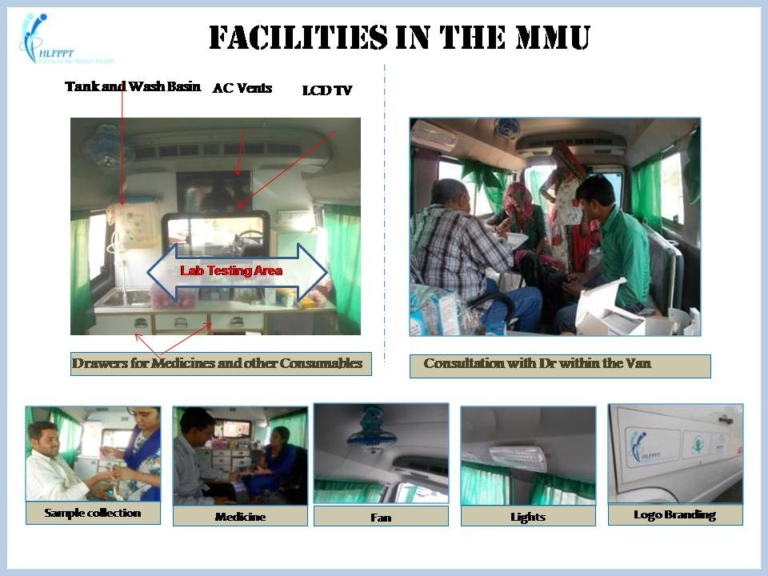

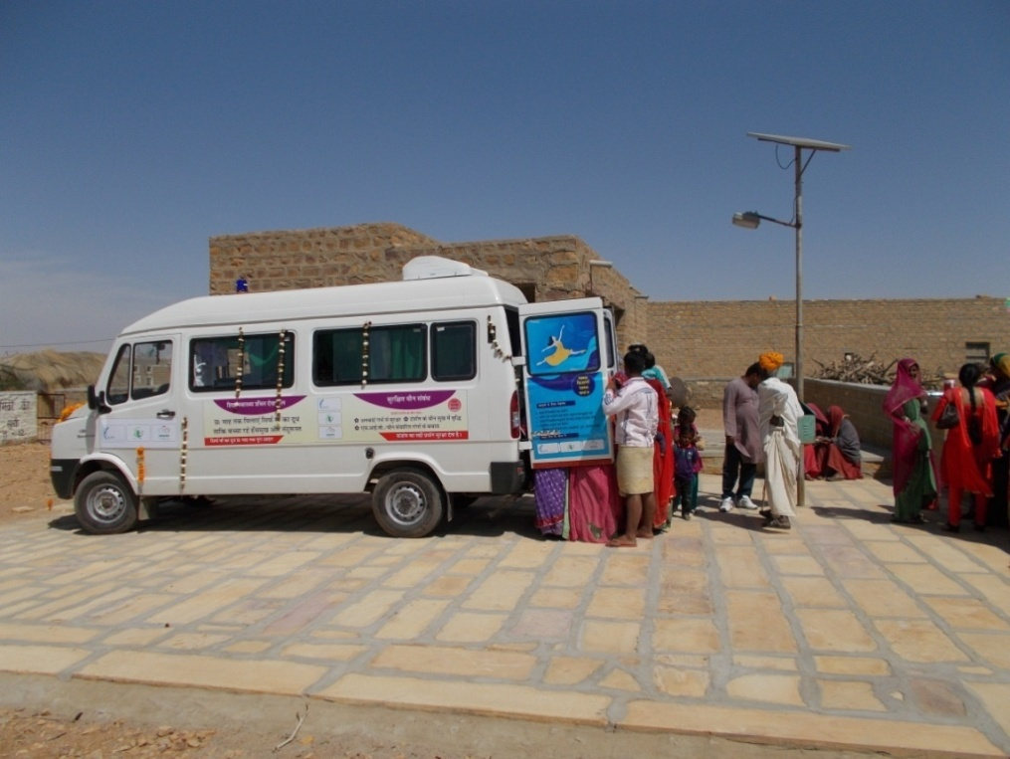

Section VIII – Geography to be Covered
The MMU vehicle will operate in 20 villages in two Gram Panchayat (Mau and Purseni), Block Mohanlaganj, Lucknow, Uttar Pradesh. The average monthly running will be 1200 Km. List of villages is given below. The list of villages /geography may change from time to time.
Sr. No | Gram Panchayat Name | Village Name
1 | Mau | Mau
2 | Mau | Diwanganj
3 | Mau | Madhav Kheda
4 | Mau | Murli Nagar
5 | Mau | Daulatganj
6 | Mau | Bhavani Kheda
7 | Mau | Raja Kheda
8 | Mau | Sital Kheda
9 | Mau | Chibry Kheda
10 | Mau | Ganesh Kheda
11 | Mau | Indrajeet Kheda
12 | Mau | Barkhakheda-I
13 | Mau | Barkhakheda- II
14 | Mau | UPC Colony
15 | Mau | Kaleswarpuram
16 | Purseni | Rani Kheda
17 | Purseni | Purseni
18 | Purseni | Nagar
19 | Purseni | Heeraman Kheda
20 | Purseni | Gopal Kheda

Annexure A- Format for Receiving the Technical Bid
Envelope – A
(To be submitted in a separate envelope duly labeled Envelope - A “Technical Bid”)

Technical Bid - Technical Bid shall comprise the following documents

Sl. No. | Particular | Details to be submitted
1 | Bidder details | Annexure A -1
2 | Annual Turnover | Annexure A- 2
3 | Declaration Form | Annexure A-3
Note: Technical Bid should be duly page numbered, otherwise will not be considered.

(On Bidder’s Letterhead)
Annexure A -1
Bidder Details: Technical Format 1
(To be submitted in Envelope A duly labeled “Technical Proposal”)

1 | Name of Organization/Individual/ Proprietary Firm/Entity of Organization (Registered under Partnership Act)/Limited Company (Registered under the Companies Act–1956) | In case of partnership firm and limited company certified copy of partnership deed/ Articles of Association and Memorandum of Association along with registration certificate of the company shall have to be enclosed.
2 | PAN | No.______________  (Copy enclosed)
3 | Sales Tax No/Service Tax No | Registration No. _________  Valid till date_____  (Copy enclosed)
4 | Address for Communication
5 | Telephone Number with STD Code
6 | Mobile Number
7 | E-mail Address for all communications
8 | Whether similar job work undertaken in the past; if so please attach details along with documentary evidences and photographs of the same.
8.1 | No. of MMU vehicle/Ambulance operated within last 3 years (if any)
8.2 | Name of the clients with address (if applicable)
8.3 | Attach copies of work orders received from the above mentioned clients:
8.4 | No. of commercial vehicles owned (copy of RCs to be enclosed):
8.5 | No. of vehicles contracted recently (Copy of contract/Work order):
9 | Total Annual Turnover (value in Rs.) for the FY 12-13, FY 13-14, FY 14-15 (attach three years balance sheet and Profit & Loss A/c duly certified by CA)
10 | Overall Manpower available with the bidder:
10.1 | No. of drivers:
10.2 | No. of skilled mechanics (if any):
11 | Details of Authorized Representative
11.1 | Name
11.2 | Designation
11.3 | Address for communication
11.4 | Telephone No with STD Code
11.5 | Mobile Number
11.6 | E-mail

Signature of Bidder with Seal

Date: _____________

(On Bidder’s Letterhead)

Annexure A - 2
Bidder’s Annual Turn Over: Technical Format 2
(To be contained in Envelope A)

Requirement:
Average annual turnover from similar works during the last 3 financial years;

To be filled in by the Bidder:
Sr. No. | Financial Year | Turn Over Amount*
1. | 2014-15
2. | 2013-14
3. | 2012-13

Signature of Bidder with Seal

Date: _____________

Supporting document:
* Attach Balance sheet and Profit & Loss A/c for FY 12-13, FY 13-14, and FY 14-15 duly certified by CA
(On Bidder’s Letterhead)

Bidder Declaration: Technical Format 3
(To be contained in Envelope A)
Annexure A - 3

Undertaking from the Bidder

In response to the RFP No: HLFPPT/CSR/MMU/LKO/2016, we have submitted our technical & financial bids for “Supply, Operations & Maintenance of Mobile Medical Unit vehicle in Mohanlalganj, Lucknow, Uttar Pradesh” at your office Hindustan Latex Family Planning Promotion Trust (HLFPPT) B-14A, Second Floor, Sector-62 Gautambudh Nagar, Noida-201 307. In connection with the above bids, we hereby declare as under:

    - That we are neither related to any of your Trustees, Officers and other employees, nor do we have any financial, commercial or other interests with any of the above persons in any capacity whatsoever.

    - That we have submitted the bids in the name of M/s…………………….......................and declare that no other bids have been submitted by us in the name of any other firms/companies/proprietors/individuals which comes under the same management and related parties.

    - We hereby undertakes that in case of any violations to the above declarations at any stage of the contract, HLFPPT reserves the sole right to cancel the Work Order and recover the full value of the Work Order from us.

Signature of Bidder of with Seal

Date: _____________

(On Bidder’s Letterhead)

Annexure B - Format for Receiving the Financial Bid

Annexure - B
Financial Bid

(To be submitted in a separate envelope duly labeled Envelope B “Financial Bid”)

NAME OF WORK: “Proposal for Supply, Operations & Maintenance of Mobile Medical Unit vehicle in Mohanlalganj, Lucknow, Uttar Pradesh”

I/We hereby bid for the execution of the above work within the time specified at the rate and amount stated by us in the Financial Bid – Annexure B in all respects and in accordance with the specifications and instructions in writing and in all respects in accordance with such conditions so far as applicable. I/We have visited the area of work and am/ are fully aware of scope of work and all the conditions likely to affect carrying out the work. I/We have fully acquainted myself/ourselves about the conditions in regard to accessibility of site, nature and the extent of road and working conditions, including movement of vehicle required for the satisfactory execution of contract.

Should this bid be accepted, I/We hereby agree to abide by and fulfill all the terms and provisions of the said conditions of contract.

Signature of Bidder of with Seal

Date: _____________

(On Bidder’s Letterhead)

Financial Format
(To be contained in Envelope B)

Unit cost of operating Mobile Medical Unit vehicle:
S.No. | Particulars | Force Traveler | Tata Winger | Eicher Canter
1 | Vehicle Model (Year of Manufacturing)  Note 1: Vehicle should not be older than Year 2014 | Year: | Year: | Year:
2 | Monthly Hiring Cost of 1 Fully Equipped MMU  Note 2: Min 1200 Kms running, 24 Days per month  [With all the suggested fabrication as mentioned under Section-III] | Monthly Cost (Rs.)
 |  | Force Traveler | Tata Winger | Eicher Canter
 |  | Rs. | Rs. | Rs.
Additional Information:
a. | Cost of extra per km (if the monthly running exceeds 1200 kms)

Note:
- The Monthly Hiring Cost of 1 Fully Equipped MMU should be inclusive of driver salary, maintenance, insurance and all taxes, and should be valid for 12 Months initially from the date of operation of the vehicle.
- HLFPPT shall provide one-time cost of branding not exceeding Rs 15,000/-

Signature of Bidder of with Seal

Date: _____________

